 | Sanjivani Rural Education Society's  SANJIVANI COLLEGE OF ENGINEERING  (An Autonomous Institution)  Kopargaon – 423 603, Maharashtra. | ACAD-F-15 K
Academic Year:  2026-27 | CIA ACTIVITY REPORT | Revision : 00
Department : | Computer Engineering | Date of Preparation
Course Code & Name: | PCCO302 : Computer Network | Year/Sem : TY/ 5th
COMPUTER NETWORKS – PROJECT REPORT
Project Title: Network Slicing in 5G and 6G
Submitted in partial fulfillment of the requirements for
PCCO302 – Computer Network
Submitted by:
Group ID: 8

Roll No | PRN No | Name of the Student | Signature
13 | 0124UCSM1013 | Rohit Gaware
22 | 0124UCSM1022 | Om Suryawanshi
25 | 0124UCSM1025 | Krishna Bachkar
43 | 0124UCSM1043 | Prathamesh Desai
TY / Semester V | Academic Year 2026–2027
Dr. P. N. Kalavadekar
Course Incharge

Certificate
This is to certify that the project report entitled “Network Slicing in 5G and 6G” is a bonafide work carried out by the following students of Sanjivani College of Engineering as part of the Computer Networks course (PCCO302) during the academic year 2026–2027.
Sr. No. | Student Name | Roll No. | PRN / Signature
1 | Rohit Gaware | 13 | 0124UCSM1013
2 | Om Suryawanshi | 22 | 0124UCSM1022
3 | Krishna Bachkar | 25 | 0124UCSM1025
4 | Prathamesh Desai | 43 | 0124UCSM1043

The work presented in this report is intended to explain the principles, architecture, use cases, opportunities, and challenges of network slicing in fifth-generation mobile networks and the anticipated evolution toward sixth-generation systems.
Project Guide: Dr. P. N. Kalavadekar
Head of Department: Prof M. A. Jawale
Place: Kopargaon

Acknowledgement
We express our sincere gratitude to Sanjivani College of Engineering for providing the academic environment and learning resources required to complete this Computer Networks project.
We are thankful to our course instructor and project guide for encouraging us to explore the emerging topic of network slicing in 5G and 6G. Their guidance helped us connect core networking concepts—such as routing, resource allocation, virtualization, quality of service, and network management—with the needs of modern mobile communication systems.
We also acknowledge the standards bodies, research communities, and technical organizations whose publications provide the foundations for understanding 5G system architecture, network slicing, service requirements, and future 6G research directions.
Finally, we thank our team members for sharing research, discussing technical concepts, reviewing the report, and organizing the information into a coherent study. This report is an academic overview; proposed 6G capabilities are described as research directions rather than finalized specifications.

Abstract
Mobile communication networks are expected to support very different services at the same time. A video-streaming user may need high data rates, an industrial controller may require predictable latency and high reliability, and a smart-city deployment may connect a very large number of low-power sensors. A single uniform network configuration cannot efficiently optimize every service for every requirement. Network slicing addresses this problem by allowing an operator to create multiple logical networks on a shared physical infrastructure, with each logical network configured for a particular service, customer, or operational objective.
This report presents the concept of network slicing, its relationship to 5G architecture, the role of the radio access network and 5G core, and the lifecycle activities used to design, instantiate, monitor, scale, and retire slices. It explains three widely used service categories—enhanced Mobile Broadband (eMBB), Ultra-Reliable Low-Latency Communications (URLLC), and massive Machine-Type Communications (mMTC)—and describes how their requirements influence resource allocation, policy, isolation, and service-level monitoring.
The report further considers security, orchestration, interoperability, economics, and operational challenges. It distinguishes established 5G concepts from anticipated 6G research directions, including AI-native management, stronger integration of communication and sensing, non-terrestrial connectivity, and more adaptive resource control. A conceptual demonstration and comparison tables are included to show how the same infrastructure can support multiple logical services. The report concludes that network slicing is a practical architectural approach to service differentiation, but its benefits depend on careful engineering, robust security, measurable service-level objectives, and transparent management.
Keywords: 5G, 6G, network slicing, 5G Core, RAN, eMBB, URLLC, mMTC, orchestration, QoS, isolation.

Table of Contents
Sr. | Chapter / Topic Description | Page
1 | Certificate | 2
2 | Acknowledgement | 3
3 | Abstract | 4
4 | Chapter 1 Introduction | 9
 | 1.1 Background | 9
 | 1.2 What is network slicing? | 9
 | 1.3 Why it matters | 9
 | 1.4 Problem statement | 9
 | 1.5 Organization of the report | 10
5 | Chapter 2 Objectives and Scope | 11
 | 2.1 Objectives | 11
 | 2.2 Scope | 11
 | 2.3 Limitations | 11
 | 2.4 Methodology | 11
6 | Chapter 3 Literature and Standards Overview | 12
 | 3.1 Standards context | 12
 | 3.2 Core ideas found in technical literature | 12
 | 3.3 Research and implementation themes | 12
 | 3.4 Reading standards carefully | 12
7 | Chapter 4 Fundamentals of Network Slicing | 14
 | 4.1 Physical infrastructure and logical networks | 14
 | 4.2 Slicing compared with traditional networks | 14
 | 4.3 Network slice, slice instance, and subnet | 14
 | 4.4 Network slicing is not the same as QoS | 14
 | 4.5 Shared resources and isolation | 14
 | 4.6 Service-level agreements | 15
8 | Chapter 5 5G Architecture for Network Slicing | 16
 | 5.1 High-level architecture | 16
 | 5.2 User Equipment (UE) | 16
 | 5.3 Radio Access Network (RAN) | 16
 | 5.4 5G Core functions | 16
 | 5.5 Transport and edge computing | 17
 | 5.6 Management and orchestration | 17
 | 5.7 End-to-end view | 17
9 | Chapter 6 Network Slice Types and Service Requirements | 18
 | 6.1 Enhanced Mobile Broadband (eMBB) | 18
 | 6.2 Ultra-Reliable Low-Latency Communications (URLLC) | 18
 | 6.3 massive Machine-Type Communications (mMTC) | 18
 | 6.4 Service requirements are multidimensional | 19
 | 6.5 Illustrative slice mapping | 19
 | 6.6 Avoiding overpromising | 19
10 | Chapter 7 Slice Lifecycle and Orchestration | 20
 | 7.1 Why lifecycle management is needed | 20
 | 7.2 Lifecycle stages | 20
 | 7.3 Orchestration and automation | 20
 | 7.4 Monitoring and feedback | 20
 | 7.5 Scaling and admission control | 21
 | 7.6 Fault handling and recovery | 21
11 | Chapter 8 Resource Allocation and Quality of Service | 22
 | 8.1 Scarce resources | 22
 | 8.2 Reservation, sharing, and priority | 22
 | 8.3 Quality of Service indicators | 22
 | 8.4 Admission control and congestion | 22
 | 8.5 Edge placement | 22
 | 8.6 Fairness and isolation | 23
12 | Chapter 9 Security, Isolation, and Privacy | 24
 | 9.1 Security objectives | 24
 | 9.2 Threats and mitigations | 24
 | 9.3 Isolation models | 24
 | 9.4 Privacy considerations | 25
 | 9.5 Security testing | 25
 | 9.6 Shared responsibility | 25
13 | Chapter 10 Applications and Industry Use Cases | 26
 | 10.1 Smart manufacturing | 26
 | 10.2 Healthcare and connected medical environments | 26
 | 10.3 Smart cities and utilities | 26
 | 10.4 Connected transport | 26
 | 10.5 Media, events, and temporary deployments | 26
 | 10.6 Enterprise and campus networks | 26
 | 10.7 Example: university campus | 26
14 | Chapter 11 Network Slicing Toward 6G | 28
 | 11.1 5G to 6G transition | 28
 | 11.2 AI-native management | 28
 | 11.3 Communication and sensing integration | 28
 | 11.4 Non-terrestrial networks and wider coverage | 28
 | 11.5 Integrated edge-cloud services | 28
 | 11.6 Energy efficiency and sustainability | 28
 | 11.7 5G and anticipated 6G comparison | 28
 | 11.8 Caution about future claims | 29
15 | Chapter 12 Conceptual Demonstration and Methodology | 30
 | 12.1 Purpose of the demonstration | 30
 | 12.2 Scenario | 30
 | 12.3 Step-by-step method | 30
 | 12.4 Example slice profiles | 30
 | 12.5 Acceptance criteria | 30
 | 12.6 Test cases | 31
 | 12.7 Data collection | 31
 | 12.8 Ethical and operational considerations | 31
16 | Chapter 13 Results, Comparison, and Discussion | 32
 | 13.1 Expected outcome of the conceptual exercise | 32
 | 13.2 Summary matrix | 32
 | 13.3 What the comparison shows | 32
 | 13.4 Conceptual results versus measured results | 32
 | 13.5 Suggested future experiment | 32
17 | Chapter 14 Advantages, Limitations, and Challenges | 33
 | 14.1 Advantages | 33
 | 14.2 Limitations | 33
 | 14.3 Major engineering challenges | 33
 | 14.4 Economic considerations | 34
 | 14.5 Governance and accountability | 34
18 | Chapter 15 Conclusion and Future Scope | 35
 | 15.1 Conclusion | 35
 | 15.2 Future scope | 35
 | 15.3 Final observation | 35
19 | Annexure A Glossary | 36
20 | Annexure B Sample Slice Requirements Template | 37
21 | Annexure C Sample KPI Dashboard Design | 38
22 | Annexure D Group Photo / Project Evidence | 39
23 | References | 40
24 | Student Declaration | 41

List of Figures
- Figure 1. High-level architecture of network slicing
- Figure 2. Network slice lifecycle
- Figure 3. Different service objectives across slice categories
- Figure 4. Security layers for a sliced network

List of Tables
- Table 1. Conventional network versus network slicing
- Table 2. Main 5G service categories
- Table 3. Network-slice design parameters
- Table 4. Illustrative slice mapping
- Table 5. Lifecycle stages and outputs
- Table 6. Security risks and mitigations
- Table 7. 5G slicing and anticipated 6G evolution

Chapter 1 : Introduction

1.1 Background
Mobile networks have evolved from systems primarily designed for voice calls to programmable platforms that support broadband, connected devices, industrial automation, transportation, healthcare, and cloud applications. As these services have different performance requirements, the network must do more than simply transfer packets from one endpoint to another. It must also provide appropriate capacity, delay, reliability, security, and operational control.
Earlier mobile generations improved capacity and coverage, but services were often delivered through broadly shared network resources with relatively uniform policies. Modern cloud-native and virtualized network functions make it possible to define logical service environments on top of common infrastructure. Network slicing is one of the mechanisms that uses this programmability to match network behaviour to service requirements.

1.2 What is network slicing?
Network slicing is the creation of multiple logical networks over a common physical network. Each slice can be configured with its own combination of network functions, connectivity characteristics, policy rules, resource allocations, and management objectives. A slice is not necessarily a physically separate collection of cables, towers, servers, and radios. Instead, it is a logical service environment whose components may share physical resources while maintaining defined separation and control.
For example, a mobile operator may provide one slice optimized for high-definition video, another for connected traffic signals, and another for a factory’s control systems. The physical infrastructure can be shared, but the slices can be managed according to different requirements and service-level agreements (SLAs).

1.3 Why it matters
- Service differentiation: networks can be tuned for throughput, latency, device density, coverage, or reliability.
- Infrastructure efficiency: shared hardware and spectrum can be used by multiple services rather than duplicating every network element.
- Faster service creation: a slice template can help an operator deploy a repeatable service configuration.
- Operational control: telemetry and policy can be used to monitor and adjust a slice during its lifetime.
- Support for enterprise services: organizations can request network behaviour tailored to their applications.

1.4 Problem statement
The central problem addressed by network slicing is how to support diverse services with conflicting requirements on a shared mobile network. Maximizing average throughput alone may not satisfy a low-latency controller, while reserving resources for every possible peak can be inefficient. The network therefore needs mechanisms to describe service intent, map it to resources, maintain isolation, and verify that the delivered service remains within its agreed objectives.

1.5 Organization of the report
The following chapters explain the foundations, architecture, service categories, lifecycle, security considerations, applications, future directions, and a conceptual demonstration. Tables and diagrams summarize the relationships among network functions, service objectives, and management activities.

Chapter 2 : Objectives and Scope

2.1 Objectives
- To explain network slicing in simple technical terms and distinguish it from ordinary traffic prioritization.
- To identify the main architectural building blocks that enable slicing in 5G systems.
- To compare eMBB, URLLC, and mMTC service categories and the design trade-offs they introduce.
- To describe slice lifecycle management, orchestration, monitoring, and resource allocation.
- To examine security, privacy, isolation, and operational challenges.
- To summarize how slicing may evolve alongside 6G research without treating future proposals as finalized standards.

2.2 Scope
The report focuses on the conceptual and architectural aspects of slicing in 5G and its possible evolution toward 6G. It discusses the radio access network (RAN), core network, management and orchestration functions, virtualized or cloud-native infrastructure, policy, and service monitoring. It uses illustrative examples to explain design decisions.

2.3 Limitations
This report is an academic study rather than a live operator deployment or a conformance test. It does not claim to measure real carrier latency, throughput, reliability, or commercial slice availability. Performance values used in the conceptual examples are qualitative or illustrative. Actual service performance depends on spectrum, radio conditions, deployment architecture, device capabilities, implementation choices, load, and the terms of an operator’s service agreement.

2.4 Methodology
The methodology consists of reviewing established standards concepts and technical literature, organizing the architecture into functional layers, comparing common service categories, and developing a conceptual scenario. The scenario is used to demonstrate how requirements can be mapped to a slice profile and which indicators should be monitored. It is not presented as experimental proof of performance.

Chapter 3 : Literature and Standards Overview

3.1 Standards context
Network slicing is associated with the broader 5G system architecture developed through 3GPP specifications. The standards describe concepts such as the 5G Core, network functions, session management, policy control, network-slice identification, and management procedures. The exact set of capabilities depends on the specification release and the operator’s implementation.
The International Telecommunication Union (ITU) provides the IMT-2020 framework and requirements context for 5G. The 3rd Generation Partnership Project (3GPP) develops detailed system specifications used by the mobile industry. The Internet Engineering Task Force (IETF) develops Internet protocols and related technologies that can be relevant to transport, security, and network programmability. The Next Generation Mobile Networks (NGMN) Alliance has published industry perspectives on 5G network slicing and service requirements.

3.2 Core ideas found in technical literature
- Service-based architecture: network functions expose services through defined interfaces, supporting modularity and flexible deployment.
- Virtualization and cloud-native operation: software functions can be deployed and scaled on shared compute infrastructure.
- End-to-end service design: a slice may involve the radio, transport, core, edge, and management systems rather than only one network segment.
- Automation: orchestration tools can translate service intent into resource and configuration actions.
- Isolation: logical separation is required so that one slice’s traffic, policies, or faults do not improperly affect another.

3.3 Research and implementation themes
Technical studies commonly examine how to allocate scarce radio resources, how to meet delay and reliability objectives, how to coordinate the RAN and core, and how to automate lifecycle operations. Other work examines security boundaries, slice admission control, cost allocation, and multi-domain orchestration. For future systems, research also considers AI-assisted management, integrated sensing and communication, non-terrestrial networks, and new spectrum opportunities.

3.4 Reading standards carefully
A standards document may define a capability without requiring every operator to expose it commercially. A research paper may report results under a specific simulation model rather than a production network. Therefore, technical claims should be read with attention to the specification release, assumptions, topology, load, and measurement method.
Source family | Main contribution | How it is used in this report
ITU-R IMT frameworks | High-level service and performance context for mobile generations | Context for 5G and future-generation objectives
3GPP specifications | Detailed 5G system architecture, network functions, and slicing concepts | Architectural terminology and lifecycle understanding
NGMN publications | Industry viewpoints on slicing, service requirements, and business models | Operational motivation and service examples
IETF standards and RFCs | Internet protocols, transport, security, and programmability | Supporting concepts where relevant
Academic research | Algorithms, optimization, orchestration, and future concepts | Discussion of trade-offs and open problems

Chapter 4 : Fundamentals of Network Slicing

4.1 Physical infrastructure and logical networks
A physical network includes radio sites, antennas, spectrum, transport links, data-centre servers, storage, and network appliances. A logical slice is created through software configuration and policy that associate selected network functions and resources with a particular service. Several slices may use the same physical site or server, but they do not need to use identical policies, routing, performance targets, or security controls.

4.2 Slicing compared with traditional networks
Aspect | Traditional uniform network approach | Network slicing approach
Service configuration | Broadly similar policies for many services | Service-specific profiles and policies
Resource planning | Capacity designed around aggregate demand | Resources can be assigned or prioritized by slice objectives
Deployment | New service may require extensive manual configuration | Templates and orchestration can support repeatable deployment
Isolation | Often based on shared network-wide controls | Explicit slice-aware separation and access controls are needed
Monitoring | Network-wide KPIs may dominate | Per-slice and end-to-end indicators can be used
Flexibility | Changes may affect a broad service population | A slice can be adapted within the limits of shared resources

4.3 Network slice, slice instance, and subnet
Terminology can vary across documents and implementation environments. In general, a network slice describes a logical network tailored to a service. A slice instance is a deployed realization of that design. A slice subnet is a portion of the overall slice, often corresponding to a domain or set of network functions such as RAN, transport, or core. These concepts help separate the service definition from the resources that implement it.

4.4 Network slicing is not the same as QoS
Quality of Service (QoS) mechanisms classify traffic and influence scheduling, queuing, packet handling, and resource treatment. Slicing is broader: it can combine QoS with network-function selection, topology, routing, capacity planning, management policy, security, and lifecycle control. QoS can be used inside a slice, and a slice may contain multiple traffic classes. Neither concept automatically guarantees performance under every load condition.

4.5 Shared resources and isolation
Slicing does not imply that every slice owns dedicated hardware. An operator may use shared servers, radio resources, and transport links. Isolation can be implemented through access controls, virtualization boundaries, resource reservations, traffic separation, policy enforcement, and monitoring. Because resources are shared, the design must account for contention, failure domains, noisy-neighbour effects, and overload.

4.6 Service-level agreements
A service-level agreement describes expected service outcomes and how they are measured. A slice profile may include throughput targets, latency objectives, availability expectations, geographic coverage, device scale, security controls, and support arrangements. A useful SLA states the measurement point, time window, percentile or threshold, exclusions, reporting method, and action when the target is not met.

Chapter 5 : 5G Architecture for Network Slicing

5.1 High-level architecture
An end-to-end slice can span user equipment, the radio access network, transport connectivity, the 5G Core, edge computing, and management systems. The architecture must associate the service request with a suitable slice, establish sessions, apply policy, and monitor whether the service continues to meet its objectives.
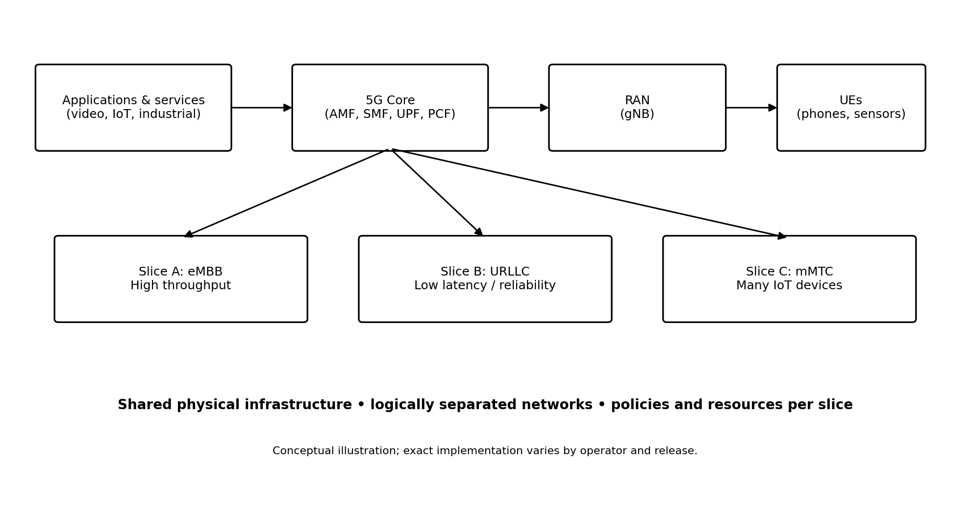
Figure 1. High-level architecture of network slicing (conceptual).

5.2 User Equipment (UE)
The UE may be a smartphone, industrial modem, vehicle unit, sensor gateway, or other device. It requests network access and may indicate supported capabilities or slice-related preferences. The network decides what access and slice services are permitted based on subscription, configuration, location, device capability, and operator policy. A device does not gain unrestricted access to any slice simply by requesting it.

5.3 Radio Access Network (RAN)
The RAN connects wireless devices to the mobile core. In 5G, a gNodeB (gNB) performs radio transmission, scheduling, mobility-related functions, and other access procedures. RAN slicing can involve sharing radio resources among service categories while applying scheduling and policy to meet differentiated objectives. Radio conditions, interference, mobility, and cell load strongly influence what can be delivered.

5.4 5G Core functions
Function | Role in simplified terms | Relevance to slicing
AMF – Access and Mobility Management Function | Manages access registration and mobility-related signalling | Supports access procedures and mobility context
SMF – Session Management Function | Establishes and manages data sessions | Helps select and manage session connectivity
UPF – User Plane Function | Forwards user data packets | Can support traffic routing, local breakout, and edge paths
PCF – Policy Control Function | Provides policy decisions | Supports policy that influences session and service treatment
UDM – Unified Data Management | Manages subscriber-related data | Provides subscription context used in authorization
NSSF – Network Slice Selection Function | Assists with slice selection-related decisions | Helps determine suitable slice options based on network policy
NRF – Network Repository Function | Supports discovery of network functions | Helps network functions discover available services

5.5 Transport and edge computing
Transport connects radio sites to core functions and data networks. A slice’s performance depends on this segment as well as on the radio and core. Edge computing places selected application or user-plane functions closer to devices, which can reduce the distance traffic travels and support local processing. Edge placement does not guarantee low latency by itself; congestion, compute scheduling, application design, and radio access remain relevant.

5.6 Management and orchestration
Management and orchestration coordinate the resources needed to deliver a slice. At a high level, an operator defines a service profile, maps it to network functions and infrastructure, instantiates the configuration, monitors operation, and changes resources when conditions change. Orchestration can span multiple administrative domains, but cross-domain coordination introduces differences in interfaces, policies, and responsibility.

5.7 End-to-end view
A slice that is optimized only in the core may still fail to meet its target if the RAN or transport network is congested. End-to-end design therefore requires a consistent service intent across domains, measurable performance indicators at meaningful points, and clear ownership of troubleshooting. The complete service path—not just a single network function—determines user experience.

Chapter 6 : Network Slice Types and Service Requirements

6.1 Enhanced Mobile Broadband (eMBB)
eMBB focuses on high data rates and capacity for applications such as high-definition video, immersive media, cloud gaming, and high-speed mobile access. The network may prioritize bandwidth, spectral efficiency, coverage, and capacity at busy locations. The main design challenge is maintaining a useful user experience as traffic demand and radio conditions change.

6.2 Ultra-Reliable Low-Latency Communications (URLLC)
URLLC represents services with demanding latency and reliability expectations, such as certain industrial control, automation, and time-sensitive communication applications. Meeting these objectives can require careful radio scheduling, short processing paths, redundancy, admission control, and deterministic application design. Low latency is an end-to-end property: application processing, transport, queues, radio retransmissions, and device behaviour all contribute.

6.3 massive Machine-Type Communications (mMTC)
mMTC addresses scenarios with very large populations of connected devices, many of which send small and infrequent messages. Examples include environmental sensors, smart meters, and some smart-city deployments. Design priorities may include device density, energy efficiency, coverage, signalling efficiency, and the ability to manage large numbers of device identities and sessions.
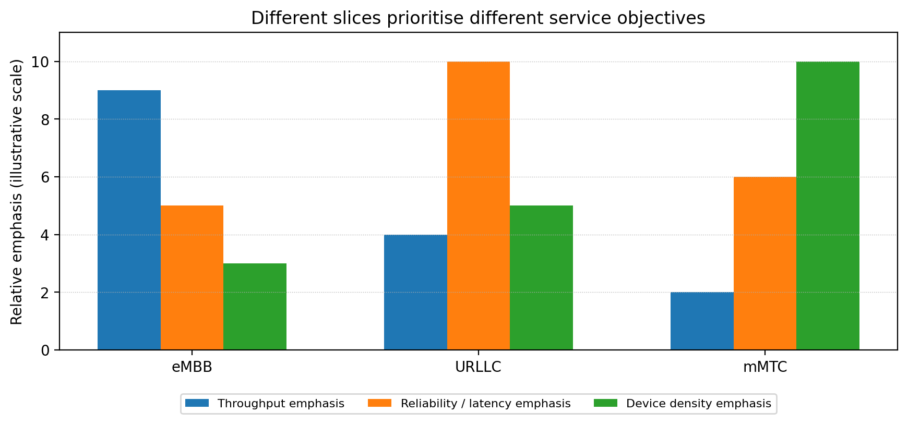
Figure 2. Different service categories emphasize different objectives. Values are illustrative, not measured performance.
Category | Typical application examples | Main priorities | Potential design trade-off
eMBB | Video, cloud applications, immersive media | Throughput, capacity, user experience | High peak rates may consume substantial shared capacity
URLLC | Industrial control, time-sensitive automation | Low latency, high reliability, predictable behaviour | May require reserved resources, redundancy, and tighter admission control
mMTC | Smart meters, environmental sensors, city telemetry | Large device count, energy efficiency, coverage | Huge device populations can create signalling and access bursts
Enterprise/private slice | Campus or factory connectivity | Local control, policy, security, predictable support | Requires integration with enterprise identity and operations
Public-safety-oriented service | Emergency coordination and mission-critical applications | Resilience, priority, coverage, controlled access | Requires careful governance, fallback plans, and validated requirements

6.4 Service requirements are multidimensional
A slice should not be defined by one number alone. Throughput, latency, jitter, packet loss, reliability, availability, device density, mobility, geographic scope, security, and cost can interact. A high-throughput service may also require broad coverage, while a low-latency service may require local processing and limited congestion. Requirements should be ranked and expressed as measurable objectives.

6.5 Illustrative slice mapping
Example service | Slice profile emphasis | Possible indicators
University video lecture | Capacity and consistent throughput | Downlink throughput, buffering events, cell utilization
Factory sensor/control | Bounded delay and reliable delivery | Latency percentiles, packet loss, availability, failover time
Smart-city meter network | Large scale and low device energy use | Successful access rate, device count, signalling load, battery profile
Campus security cameras | Uplink capacity and controlled access | Uplink throughput, loss, retention path, access logs
Mobile health telemetry | Coverage, privacy, availability, dependable delivery | Delivery success, coverage, latency, access audit events

6.6 Avoiding overpromising
The labels eMBB, URLLC, and mMTC are useful service categories, not automatic guarantees. A real deployment must specify the exact service target, measurement conditions, geographic scope, device assumptions, and failure handling. Critical applications should not rely on a marketing label alone; they require validated end-to-end engineering and appropriate operational safeguards.

Chapter 7 : Slice Lifecycle and Orchestration

7.1 Why lifecycle management is needed
A slice is not a static configuration that is created once and then forgotten. Demand changes by time and location, new devices join, applications are upgraded, and network faults occur. Lifecycle management provides repeatable steps for designing, deploying, operating, optimizing, and retiring a slice.
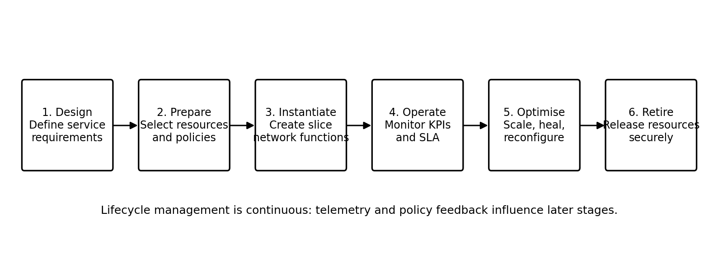
Figure 3. Typical lifecycle stages for a network slice.

7.2 Lifecycle stages
Stage | Main activities | Typical outputs
Design | Collect service requirements, define objectives and scope | Slice template, KPI definitions, security requirements
Prepare | Check capacity, dependencies, policies, and compatibility | Approved resource plan and deployment configuration
Instantiate | Create or configure network functions, connectivity, and policies | Operational slice instance
Operate | Monitor performance, faults, security events, and SLA indicators | Dashboards, alarms, reports, incident records
Optimize | Scale, re-route, tune policies, or heal failures | Updated configuration and performance evidence
Retire | Remove access, release resources, archive records, handle data safely | Decommissioning record and reclaimed resources

7.3 Orchestration and automation
Orchestration translates a service-level request into coordinated technical actions. These can include selecting network functions, provisioning virtual resources, configuring connectivity, applying policies, assigning identifiers, and connecting monitoring systems. Automation reduces repetitive manual work, but only when templates and dependencies are correct. Poor automation can reproduce a configuration error at scale.

7.4 Monitoring and feedback
Monitoring should include both infrastructure indicators and service-level indicators. Infrastructure indicators may include CPU, memory, radio utilization, transport congestion, and function health. Service indicators may include latency percentiles, packet loss, successful session establishment, throughput, and availability. Correlating these views helps operators identify whether a service issue originates in the radio, transport, core, edge, or application.

7.5 Scaling and admission control
When demand rises, an orchestrator may scale software functions or adjust resource allocation, if capacity and policy permit. Admission control determines whether a new service request can be accepted without undermining existing commitments. It is often safer to reject or defer a request than to accept more traffic than the network can support. Scaling is constrained by physical spectrum, transport capacity, hardware, licensing, and geographic coverage.

7.6 Fault handling and recovery
A resilient slice design identifies failure modes and defines recovery actions. Examples include restarting a failed software function, shifting traffic to another path, moving processing to another edge location, or notifying an enterprise operator. Recovery time, data loss, state synchronization, and the risk of affecting neighbouring slices should be considered during design and testing.

Chapter 8 : Resource Allocation and Quality of Service

8.1 Scarce resources
Radio spectrum, transport bandwidth, compute capacity, storage, and energy are limited. Slicing introduces a way to assign these resources according to service requirements, but it does not create additional physical capacity. Resource planning must therefore balance guaranteed commitments, statistical sharing, expected peaks, and protection against overload.

8.2 Reservation, sharing, and priority
A slice may receive a reserved share of a resource, a priority relative to other traffic, or access to a shared pool subject to policy. Reservation can improve predictability but may leave resources unused during quiet periods. Pure sharing can improve utilization but may create contention during simultaneous demand peaks. A practical design often combines baseline reservations, controlled sharing, and admission limits.

8.3 Quality of Service indicators
Indicator | Meaning | Why it matters
Throughput | Rate of successfully delivered data | Important for video, downloads, and high-volume data
Latency | Time taken for data to travel between defined points | Important for interactive and time-sensitive services
Jitter | Variation in packet delay | Can affect real-time audio, video, and control loops
Packet loss | Fraction of packets not successfully delivered | Can harm application quality and control reliability
Availability | Proportion of time a service is usable under a defined measure | Important for services that must remain accessible
Reliability | Probability of successful delivery under defined conditions | Important for critical communication
Device/session scale | Number of devices or sessions supported | Important for IoT and large deployments

8.4 Admission control and congestion
A slice manager needs a way to decide whether the network can support a requested service. Admission decisions should consider current load, expected peak demand, service priority, geographic area, and failure scenarios. Congestion can arise even when average utilization appears acceptable, because traffic is bursty and bottlenecks may occur in one cell, transport link, or processing node.

8.5 Edge placement
Placing user-plane processing or applications near the access network can shorten some traffic paths and reduce backhaul use. However, edge locations may have less compute capacity than central data centres, and applications may depend on centralized services. The edge decision should therefore balance latency, cost, resilience, data locality, and operational complexity.

8.6 Fairness and isolation
Resource management must protect one service from uncontrolled interference by another while avoiding unnecessary waste. Fairness does not always mean equal allocation: services may have different commitments and priorities. The operator should document the policy used to allocate resources, how exceptions are handled, and how the policy is tested under congestion.

Chapter 9 : Security, Isolation, and Privacy

9.1 Security objectives
A sliced network must protect confidentiality, integrity, availability, identity, and administrative control. Because multiple logical services share infrastructure, a security failure in one layer can affect more than one slice if boundaries are weak. Security must therefore be considered across the device, access network, core, transport, cloud infrastructure, management systems, and application.
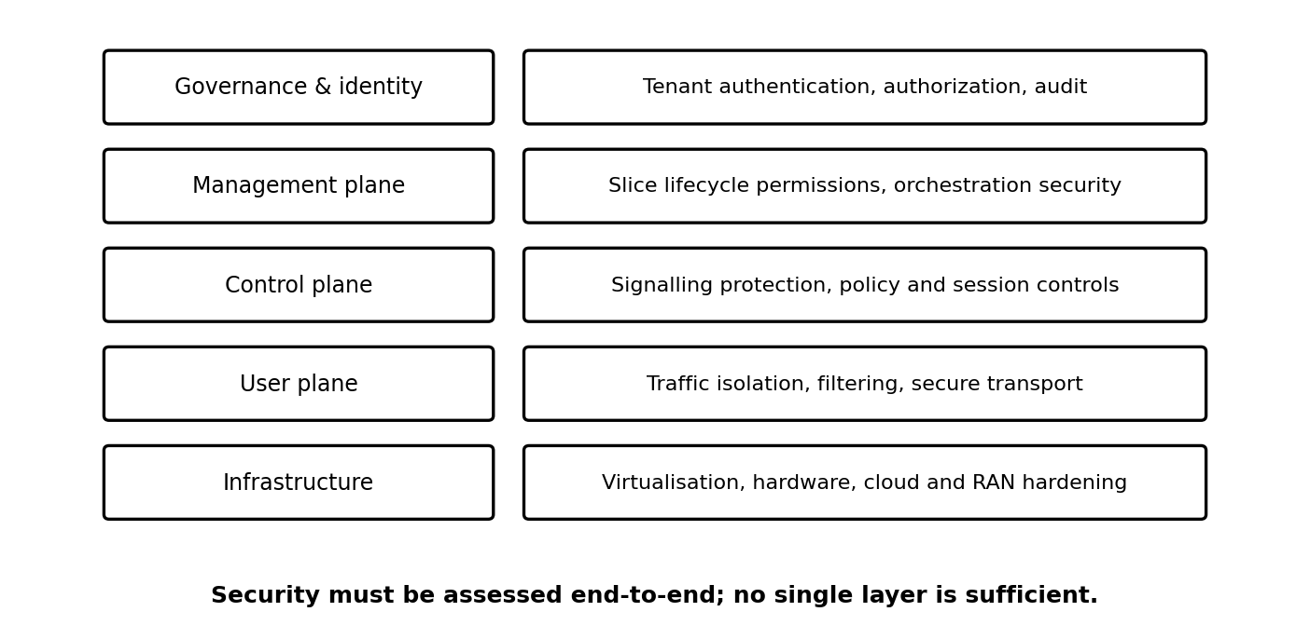
Figure 4. Security is a set of connected layers rather than a single control.

9.2 Threats and mitigations
Risk | Example impact | Possible mitigation
Unauthorized slice access | A device or tenant uses a service it is not entitled to access | Strong authentication, authorization, subscription checks, least privilege
Cross-slice interference | Excess load or a fault affects another service | Resource quotas, isolation controls, admission control, stress testing
Compromised orchestration | An attacker changes slice policies or deployment settings | Role-based access, multi-factor authentication, signed changes, audit trails
Misconfigured network function | Traffic is routed incorrectly or exposed | Configuration validation, change review, automated tests, rollback
Telemetry exposure | Operational data reveals sensitive patterns | Data minimization, access restrictions, retention limits, encryption
Supply-chain weakness | Vulnerable software or images are deployed | Trusted sources, vulnerability management, patching, image signing
Denial of service | Signalling or traffic overload degrades a service | Rate limits, anomaly detection, capacity planning, recovery procedures

9.3 Isolation models
Isolation may be logical, resource-based, administrative, or a combination of these. Logical isolation can separate traffic and policies. Resource isolation can limit compute, memory, bandwidth, or radio scheduling resources. Administrative isolation can ensure that one tenant cannot change another tenant’s configuration. Stronger separation may require dedicated resources, which can increase cost and reduce sharing efficiency.

9.4 Privacy considerations
Network telemetry can reveal location patterns, device behaviour, industrial operations, or personal usage. A slice should collect only the data required for operation and assurance, protect it in transit and at rest, restrict access, and define retention periods. Operators should also consider whether enterprise customers have legitimate access to the data they request and whether that access could expose other tenants.

9.5 Security testing
- Validate authorization for slice selection, management interfaces, and APIs.
- Test whether one slice can exhaust shared compute, radio, or transport resources.
- Review configuration and software images before deployment.
- Simulate component failure and verify that recovery does not bypass security controls.
- Monitor access logs, configuration changes, unusual signalling, and service anomalies.
- Reassess the threat model whenever the slice, application, or deployment domain changes.

9.6 Shared responsibility
Responsibility is distributed among the mobile operator, infrastructure provider, cloud provider, enterprise customer, application owner, and device vendor. Contracts and operational procedures should clarify who patches each component, who responds to incidents, who can view telemetry, and who is authorized to change service policy.

Chapter 10 : Applications and Industry Use Cases

10.1 Smart manufacturing
Factories may connect sensors, mobile robots, cameras, handheld terminals, and industrial controllers. These applications differ in traffic volume and delay tolerance. A sliced architecture can separate high-volume inspection video from control traffic and routine sensor telemetry, while aligning policies with factory zones and operational requirements. A production design must still evaluate radio coverage, interference, deterministic control needs, fail-safe behaviour, and integration with existing industrial networks.

10.2 Healthcare and connected medical environments
Hospitals may use connected equipment, patient-monitoring devices, mobile workstations, and high-resolution imaging. Slicing can help organize service policies for different classes of traffic. It does not replace clinical validation, medical-device regulation, privacy controls, or redundant communications where needed. Critical medical workflows should have a tested fallback when wireless connectivity is unavailable.

10.3 Smart cities and utilities
City infrastructure can include smart meters, environmental monitors, parking sensors, street lighting, and traffic-management devices. Large device populations may generate low average traffic but occasional bursts of signalling. Slice planning should account for geographic coverage, battery life, device onboarding, security updates, and long equipment lifecycles.

10.4 Connected transport
Transport applications can include passenger connectivity, fleet monitoring, road-side sensing, and selected vehicle-to-network services. Their requirements differ: passenger broadband is throughput-oriented, while safety-related communication may require carefully engineered reliability and delay bounds. A network slice should be one part of a broader safety architecture, not the only protection mechanism.

10.5 Media, events, and temporary deployments
Stadiums, concerts, and large public events can create concentrated traffic peaks. An operator may plan capacity and policies for event-oriented services, such as high-volume video, operational staff communication, and connected devices. Temporary slices require advance planning, coverage validation, admission control, and a retirement process after the event.

10.6 Enterprise and campus networks
Enterprises may need predictable access for business applications, separate policies for guest devices, or local routing for sensitive workloads. Slicing can support service differentiation, but it is not identical to a private 5G network. Depending on the solution, an enterprise may use a public-network slice, a dedicated private network, or a hybrid arrangement. Selection depends on ownership, coverage, control, cost, and security requirements.

10.7 Example: university campus
Consider a university campus that uses one mobile infrastructure for student internet access, campus security cameras, laboratory sensors, and building automation. A conceptual design could define separate service profiles: one for student broadband, one for camera uplink, one for sensor telemetry, and one for time-sensitive laboratory equipment. Each profile would have its own access policy, traffic objectives, monitoring indicators, and escalation process.
Campus service | Primary need | Possible policy choice | Monitoring focus
Student broadband | High aggregate capacity | Best-effort service with congestion management | Throughput, user experience, cell load
Security cameras | Reliable uplink and controlled access | Authorized endpoints and defined traffic paths | Uplink loss, availability, access logs
Environmental sensors | Large device population and low power | Efficient periodic reporting and device authentication | Successful reporting, device health
Laboratory automation | Predictable response within a validated scope | Controlled admission and local processing where suitable | Latency percentiles, packet loss, recovery

Chapter 11 : Network Slicing Toward 6G

11.1 5G to 6G transition
6G is an evolving research and standardization area rather than a single fully deployed system. Future-generation networks are expected to investigate more demanding requirements for capacity, responsiveness, coverage, energy efficiency, trustworthiness, and integration with computing and sensing. Network slicing may continue as a service-differentiation concept, but its architecture, automation, and relationship with other capabilities may change.

11.2 AI-native management
Machine-learning methods may help predict demand, detect anomalies, recommend resource changes, and optimize energy use. For slicing, AI-assisted management could estimate when a slice is likely to breach a service objective and propose scaling or policy adjustments. These methods need reliable training data, explainability appropriate to the task, safeguards against unsafe actions, and fallback mechanisms when models are uncertain or wrong.

11.3 Communication and sensing integration
Future systems may combine communication with sensing functions, allowing radio signals and network infrastructure to support selected environmental or object-detection tasks in addition to data transfer. This could create new service profiles, but sensing introduces privacy, accuracy, and governance questions. A future slice may need to describe not only communication performance but also sensing quality and permitted use of collected information.

11.4 Non-terrestrial networks and wider coverage
Satellites and other non-terrestrial platforms may complement terrestrial networks to extend coverage to remote regions, transport routes, and areas affected by infrastructure disruption. End-to-end slicing across terrestrial and non-terrestrial domains would require coordination of mobility, delay, capacity, security, and service continuity. Different link characteristics mean that one slice template may not fit every access type.

11.5 Integrated edge-cloud services
Future networks may treat communication and computation as a coordinated service. A slice could be associated with edge application resources, data-processing locations, and transport paths. Such coordination can improve application efficiency, but it increases orchestration complexity and requires clear interfaces between network and cloud management.

11.6 Energy efficiency and sustainability
Energy efficiency is likely to remain an important design goal. Slice-aware management could adjust capacity or processing resources according to demand, while preserving service requirements. However, aggressive sleep modes or scaling actions may increase wake-up delay or reduce resilience. Energy optimization should therefore be measured alongside service quality.

11.7 5G and anticipated 6G comparison
Dimension | 5G slicing context | Possible 6G direction (research / anticipated)
Service differentiation | Slices support distinct service requirements | More dynamic, application- and context-aware service profiles
Management | Automation and orchestration across network domains | Greater use of AI-assisted closed-loop management
Connectivity | Terrestrial mobile access with evolving non-terrestrial integration | More seamless terrestrial, aerial, and satellite coordination
Computing | Edge computing can support selected low-latency services | Tighter communication-computation co-design
Sensing | Primarily communication-focused network services | More integrated sensing and communication capabilities may be explored
Energy | Efficiency is an operator and system design concern | More explicit energy-aware optimization may be investigated
Standards status | 5G architecture is specified through established standards | 6G requirements and designs remain under research and standardization

11.8 Caution about future claims
The features discussed in this chapter should be understood as possible directions, not promises that every 6G network will implement every capability. Research concepts must pass through feasibility studies, standardization, implementation, interoperability testing, regulation, and commercial deployment before their real-world capabilities can be assessed.

Chapter 12 : Conceptual Demonstration and Methodology

12.1 Purpose of the demonstration
The following demonstration shows how a network operator could reason about multiple service requests on shared infrastructure. It is a conceptual planning exercise, not a simulation or measurement of a live 5G network. The goal is to illustrate requirement capture, slice mapping, KPI selection, and the operational checks needed before a slice is considered ready.

12.2 Scenario
Assume a campus network supports three groups of users: students streaming learning content, laboratory equipment sending time-sensitive messages, and environmental sensors reporting readings. The operator collects each group’s requirements and decides whether they can be supported using separate slice profiles on shared radio, transport, core, and edge resources.

12.3 Step-by-step method
- Identify each application, endpoint type, geographic scope, traffic pattern, and criticality.
- Define measurable objectives such as throughput, latency, loss, availability, device count, and security.
- Map the objectives to a slice profile and decide which resources may be shared or reserved.
- Check capacity under normal load, peak demand, and a reasonable failure scenario.
- Configure authentication, authorization, traffic policies, routing, and monitoring.
- Run acceptance tests with representative devices and realistic traffic patterns.
- Monitor performance continuously and revise the design when measurements or requirements change.

12.4 Example slice profiles
Profile | Traffic pattern | Priority of design | Acceptance test example
Campus broadband | Large and variable downlink bursts | Capacity and user experience | Measure throughput and buffering at busy times
Laboratory control | Small messages with strict timing assumptions | Bounded end-to-end delay and reliable delivery | Measure latency percentiles and loss under load
Environmental IoT | Many devices sending periodic small payloads | Device scale, coverage, energy efficiency | Test mass registration and reporting bursts

12.5 Acceptance criteria
Acceptance criteria should be agreed before deployment. Each criterion must define the measurement point, traffic profile, time window, target, test load, and response if the target is missed. For example, a latency objective should state whether it measures radio access, user-plane transport, or application response. Ambiguous criteria make it difficult to determine whether a service is meeting its commitment.

12.6 Test cases
Test ID | Test objective | Method | Expected observation
T1 | Verify authorized slice access | Attempt access with permitted and unpermitted profiles | Only authorized requests are accepted
T2 | Observe service differentiation | Generate representative traffic for each profile | Policies and KPIs reflect the intended service priorities
T3 | Check load behaviour | Increase background traffic within a planned test range | Critical profile remains within its validated limits or raises an alarm
T4 | Check fault response | Simulate a controlled component or path failure | Recovery follows the documented procedure
T5 | Check monitoring | Trigger a known KPI threshold or test event | Dashboard and alert identify the affected service
T6 | Check isolation | Attempt cross-tenant access and controlled resource stress | No unauthorized access; resource boundaries operate as designed

12.7 Data collection
A practical study would record timestamped KPI measurements, configuration versions, traffic-generation settings, device type, radio conditions, and the exact topology. Results should include sample counts and test duration. Without these details, a reported average can hide bursts, tail latency, or intermittent failures.

12.8 Ethical and operational considerations
Testing should be authorized, conducted in a controlled environment, and designed not to disrupt public services or other tenants. Data collection should avoid unnecessary personal information. Any production trial should have a rollback plan and a responsible operator monitoring the test.

Chapter 13 : Results, Comparison, and Discussion

13.1 Expected outcome of the conceptual exercise
The conceptual exercise demonstrates that service differentiation starts with requirements rather than with a technology label. Student broadband, laboratory control, and environmental IoT traffic have different patterns and success criteria. A single shared infrastructure can support these services only if the operator maps requirements to policies, resources, monitoring, and admission decisions.

13.2 Summary matrix
Evaluation area | Broadband profile | Control profile | IoT profile
Traffic volume | High and variable | Usually lower volume | Low per device, large aggregate population
Latency sensitivity | Moderate, application-dependent | High for selected applications | Often tolerant of delay, application-dependent
Scale | Many users | Limited endpoints in example | Potentially very large device count
Key risk | Congestion and poor user experience | Delay variation or packet loss | Access bursts and device-management scale
Primary KPIs | Throughput, buffering, cell utilization | Latency, loss, availability | Registration success, reporting rate, device health

13.3 What the comparison shows
First, service profiles need different combinations of KPIs. Second, the same physical bottleneck can affect multiple slices, so logical separation does not eliminate capacity planning. Third, monitoring must connect technical measurements with service-level outcomes. Fourth, security is not separate from performance: authentication storms, misconfiguration, or a compromised tenant can create service disruptions.

13.4 Conceptual results versus measured results
No live network measurements were collected for this report. Therefore, the result is an architectural analysis rather than a numerical performance claim. A real experiment would need a defined testbed, traffic generators, repeatable load conditions, an agreed measurement method, and a baseline comparison. The qualitative comparison is useful for planning but cannot establish a particular latency, throughput, or reliability level.

13.5 Suggested future experiment
A follow-on project could implement a small virtualized testbed with separate traffic classes, policy controls, monitoring dashboards, and controlled background load. The study could compare a baseline configuration with a slice-aware configuration, while reporting throughput, latency percentiles, packet loss, CPU use, and resource utilization. Any conclusions should be limited to the testbed and configuration actually evaluated.

Chapter 14 : Advantages, Limitations, and Challenges

14.1 Advantages
- Supports service-specific network behaviour over shared infrastructure.
- Can improve infrastructure utilization compared with duplicating all resources for every service.
- Enables repeatable service deployment through templates and orchestration.
- Provides a framework for enterprise-specific policy, monitoring, and service agreements.
- Can help operators align capacity planning with measurable application needs.
- Creates a structured way to separate operational domains and service priorities.

14.2 Limitations
- Slicing cannot create extra spectrum, transport bandwidth, compute capacity, or geographic coverage.
- Logical separation does not automatically provide complete security or performance isolation.
- End-to-end management is complex when multiple vendors and administrative domains are involved.
- Service-level guarantees are difficult when radio conditions and demand change rapidly.
- More slice types increase operational complexity, testing needs, and monitoring volume.
- Commercial availability and supported features vary by operator, region, device, and release.

14.3 Major engineering challenges
Challenge | Why it occurs | Practical response
End-to-end coordination | RAN, transport, core, edge, and applications are managed differently | Define shared service intent, interfaces, and escalation paths
Dynamic resource allocation | Demand and radio conditions vary by time and location | Use telemetry, admission control, and validated automation
Interoperability | Vendor functions and APIs may differ | Test interfaces and maintain versioned configurations
Assurance | A slice may meet local metrics but fail end-to-end | Measure service-level outcomes across the full path
Security | Shared infrastructure creates cross-domain risk | Apply least privilege, isolation tests, and continuous monitoring
Cost and business model | Dedicated capacity and operations add expense | Match service commitments to customer value and measured demand
Skills and operations | Teams need knowledge across networking, cloud, automation, and security | Use clear runbooks, training, and change-control processes

14.4 Economic considerations
A slice can create value when customers need a differentiated service that justifies the associated resources and operational effort. The cost model should account for infrastructure, software licences, integration, support, monitoring, security, and capacity held in reserve. Overly granular slicing may increase complexity without enough customer benefit; overly broad slicing may fail to satisfy different applications.

14.5 Governance and accountability
A robust deployment needs clear definitions of who owns a slice, who can request changes, who approves resource increases, who sees telemetry, and who is accountable during an incident. Service catalogues, configuration baselines, change logs, and periodic reviews help prevent operational ambiguity.

Chapter 15 : Conclusion and Future Scope

15.1 Conclusion
Network slicing is an important concept in 5G because it allows a mobile operator to create logical service environments on shared physical infrastructure. By combining service profiles, network functions, policy, resource allocation, and lifecycle management, slicing can support services with different requirements for capacity, delay, device scale, security, and operational control.
The report has shown that slicing is broader than traffic prioritization. It may involve the RAN, transport, 5G Core, edge computing, orchestration, and end-to-end monitoring. eMBB, URLLC, and mMTC illustrate why different services require different design choices. The report also highlighted that isolation, security, admission control, and measurable service-level objectives are essential to successful operation.
Slicing is not a guarantee of unlimited performance. Physical resources remain finite, radio conditions change, and failures can cross logical boundaries when the design is weak. The operator must validate a service against explicit requirements and monitor it throughout its lifecycle. Future 6G research may extend slicing through AI-assisted management, integrated communication and sensing, broader connectivity, and tighter communication-computation coordination, but these directions should not be treated as finalized capabilities.

15.2 Future scope
- Build a small testbed to compare slice-aware and baseline traffic handling under controlled load.
- Explore AI-assisted prediction for capacity demand and service-level objective violations.
- Investigate cross-domain orchestration between RAN, transport, core, and edge resources.
- Study slice isolation and security testing under resource stress and configuration faults.
- Evaluate energy-aware scaling while tracking service quality and recovery time.
- Examine how terrestrial and non-terrestrial access could be coordinated for future services.

15.3 Final observation
The value of network slicing comes from matching a service’s real needs to measurable network behaviour. The strongest designs combine clear requirements, sound architecture, security-by-design, realistic capacity planning, transparent monitoring, and disciplined lifecycle management.

Annexure A : Glossary
Term | Meaning
5G Core (5GC) | Core network architecture used in 5G systems
AMF | Access and Mobility Management Function
API | Application Programming Interface
eMBB | Enhanced Mobile Broadband
gNB | 5G base station / next-generation Node B
IoT | Internet of Things
KPI | Key Performance Indicator
mMTC | massive Machine-Type Communications
NSSF | Network Slice Selection Function
Orchestration | Coordinated provisioning and management of network resources
PCF | Policy Control Function
QoS | Quality of Service
RAN | Radio Access Network
SLA | Service-Level Agreement
SMF | Session Management Function
UE | User Equipment
UPF | User Plane Function
URLLC | Ultra-Reliable Low-Latency Communications

Annexure B : Sample Slice Requirements Template
This template can be used to describe a proposed slice before implementation. Values should be completed by the service owner and network operator; the examples below are prompts, not universal requirements.
Field | Questions to answer
Service name and owner | What application is being supported and who is accountable?
Geographic scope | Which sites, cells, buildings, roads, or regions are included?
Endpoints and scale | What device types are used, and how many devices/sessions are expected?
Traffic profile | What are typical and peak rates, packet sizes, and traffic directions?
Performance objectives | Which throughput, latency, jitter, loss, reliability, and availability measures matter?
Security requirements | How are devices authenticated, traffic protected, and privileges restricted?
Resource model | Which resources are reserved, shared, prioritized, or subject to admission control?
Monitoring | Where are KPIs measured, what thresholds trigger alerts, and who receives them?
Failure handling | What happens if a function, link, cell, or edge site fails?
Change and retirement | Who approves changes, and how is the slice decommissioned?

Annexure C : Sample KPI Dashboard Design
A practical dashboard should display service-level outcomes alongside infrastructure health. The following layout is an example of what could be monitored in a real deployment.
Dashboard panel | Example metrics | Operational question
Service quality | Throughput, latency percentiles, loss, availability | Is the service meeting its agreed objective?
Radio health | Signal quality, cell utilization, retransmissions, mobility events | Is access-network performance the limiting factor?
Transport health | Link utilization, queue depth, packet drops, path status | Is there a bottleneck between access and core/edge?
Core and edge | Function health, CPU, memory, session success, processing delay | Are software functions or compute resources overloaded?
Security | Authentication failures, denied access, configuration changes, anomalies | Is access controlled and is suspicious activity visible?
Capacity and forecasts | Peak demand, growth trends, admission requests | Can new requests be accepted without harming existing services?

Annexure D : Group Photo / Project Evidence
Presentation Geo Tag Photo
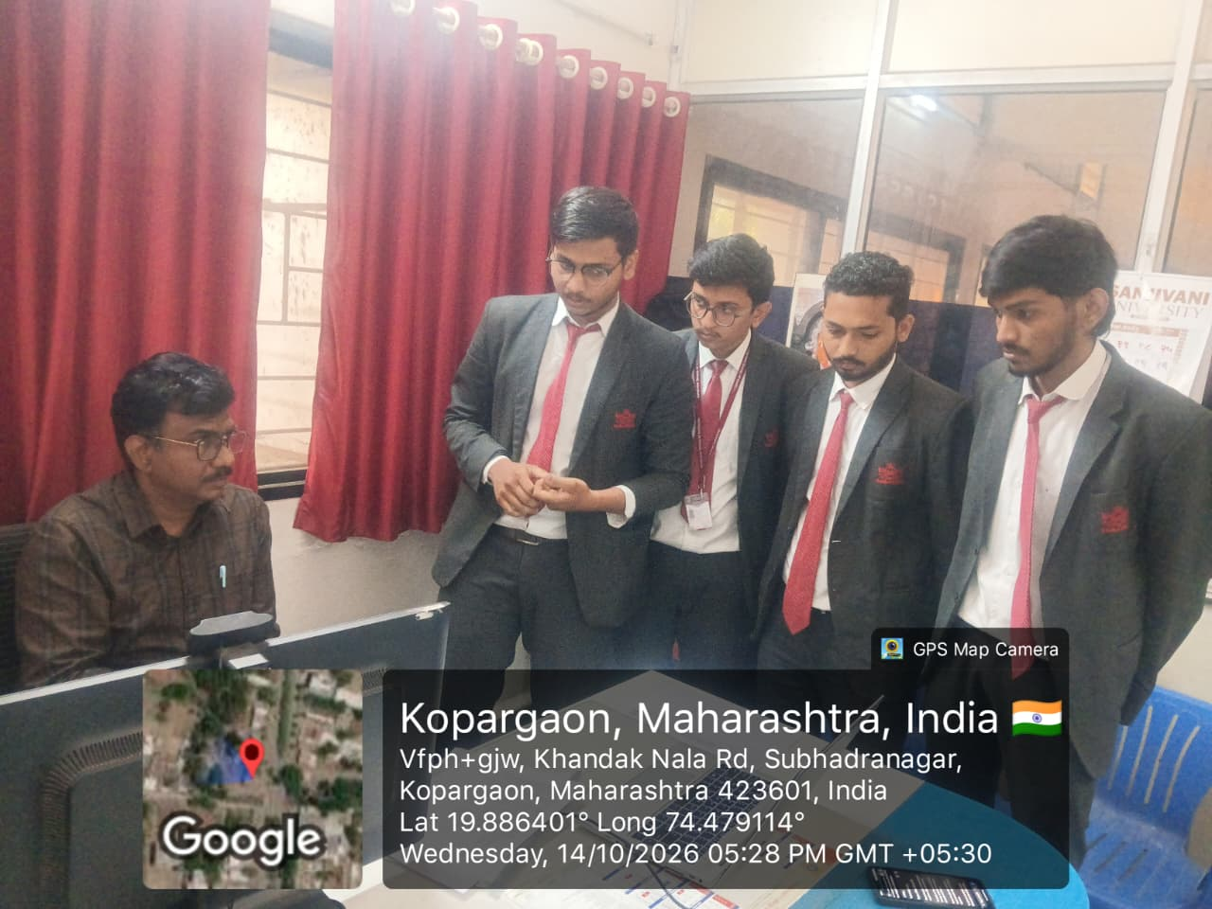

References
[1] 3rd Generation Partnership Project (3GPP), TS 23.501, System Architecture for the 5G System (5GS). Consult the applicable release for the specific architecture version.
[2] 3rd Generation Partnership Project (3GPP), TS 23.502, Procedures for the 5G System (5GS).
[3] 3rd Generation Partnership Project (3GPP), TS 28.530, Management and orchestration of networks and network slicing; concepts, use cases and requirements.
[4] 3rd Generation Partnership Project (3GPP), TS 28.531, Management and orchestration of networks and network slicing; provisioning.
[5] International Telecommunication Union, ITU-R Recommendation M.2083, IMT Vision – Framework and overall objectives of the future development of IMT for 2020 and beyond.
[6] International Telecommunication Union, ITU-R Recommendation M.2150, Detailed specifications of the terrestrial radio interfaces of International Mobile Telecommunications-2020 (IMT-2020).
[7] NGMN Alliance, 5G End-to-End Architecture Framework and related publications on 5G network slicing.
[8] Internet Engineering Task Force (IETF), RFC 8402, Segment Routing Architecture, 2018.
[9] Internet Engineering Task Force (IETF), RFC 9315, Segment Routing over IPv6 (SRv6) Network Programming, 2022.
[10] GSMA, public resources and reports on 5G network slicing and enterprise connectivity.
[11] Research literature on 5G network slicing, resource allocation, isolation, orchestration, and AI-assisted network management. Exact paper selection should be aligned with the instructor’s required citation style.
[12] Course notes and classroom discussions for PCCO302 – Computer Network, Sanjivani College of Engineering.
Note: Confirm the latest applicable release, publication title, and bibliographic details from the official publisher before final submission. Future 6G directions in this report are presented as research themes, not as finalized deployed specifications.

Student Declaration
We declare that this report has been prepared for academic study of network slicing in 5G and 6G. External standards and technical sources are acknowledged in the references. Any final submission should be reviewed by the group to ensure that it follows the department’s formatting, citation, and originality requirements.
Student signatures:
1. Rohit Gaware: __________________________
2. Om Suryawanshi: ________________________
3. Krishna Bachkar: ________________________
4. Prathamesh Desai: _______________________

